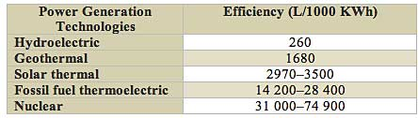

FROM IEEE SPECTRUM

1000/260 = 3.8461538461 KWh per litre

<http://spectrum.ieee.org/energy/environment/how-much-water-does-it-take-to-make-electricity>

P=\eta\rho\,Qgh\!

where

* P is power in watts
* η is the dimensionless efficiency of the turbine (0.85 percent)
* ρ is the density of water in kilograms per cubic metre 1000
* Q is the flow in cubic metres per second
* g is the acceleration due to gravity
* h is the height difference between inlet and outlet

(TUMUT 2) Water flows through the turbines at the rate of 118.9 cubic metres per second

118.9\*0.85\*1000\*9.81\*262.1 = 259.9 MW